Problem Statement: **Generate idea about how to increase revenue for the resort so that business could regain additional chair cost of $1,540,000 and maintain their profit to 9.2% or more in 1 year.**

Considering above problem statement and to recommendations on recouping the increased operating costs from the new chair this season. I have collected data from other resorts and compared various factors with our resort. Along with minor factors, I have considered below major factors to cross-check conditions with our resort.

* Ticket price for an adult
* Summit Elevation: Elevation of the summit mountain at the resort
* Vertical Drop: Vertical change in elevation from the summit to the base in feet
* Resort open Last Year
* Resort open this Year

As part of review, I have generated figures to visualize the data. Here I have divided the number of resorts into 2 groups (represent data in different color) based on their factor’s property and related data for Big Mountain resort in Red notation.

1. Summit Elevation & Vertical Drop for Blue Mountain Resort (Red Notation) vs Other Resort

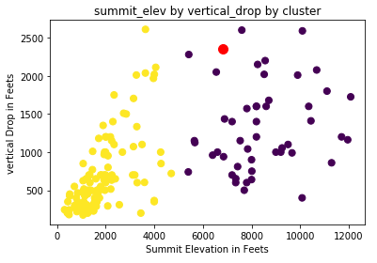

From above figure, we can conclude that Blue Mountain Resort comes under second group where we have high Summit Elevations and high Vertical Drops. Even we are among top resorts when it comes to vertical drop factor, which leads to high tourist attraction and installing an additional chair lift to help increase the distribution of visitors across the mountain could result into fruitful option we considered.

1. Projected days: Resort will be open in upcoming session against Resort open last Year (Blue Mountain Resort in Red Notation vs Other Resorts)

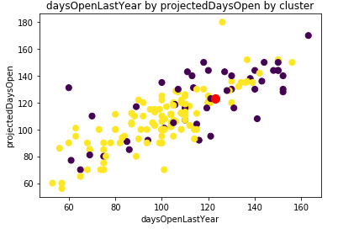

From above figure we could is there is no difference between number of days resort will be open in upcoming session and number of days resort was open last year. Therefore, depending on such factors to maintain revenue will not be feasible. Here, we should have control on factors to make sure revenue is increased/maintained.

1. Weekday and Weekend price for Blue Mountain Resort (Red Notation) vs Other Resort

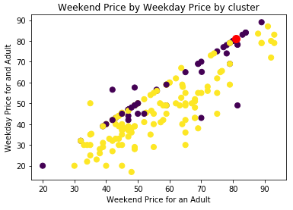

From above figure, we can conclude that for Blue Mountain Resort, price for an Adult on Weekdays and Weekends are same. Being among top resorts for vertical Drops ticket prices for our resort are still not high as other resorts. We can consider increasing ticket price of an adult. Here increasing Weekend Ticket price would be feasible as it will balance tourists with Weekday price. They can visit to resort as per their priority factors.

**After analysis on the available data of other resorts, to increase/maintain the revenue for Blue Mountain Resort I recommend here to increase ticket price for an adult on Weekends from 81 to 86.**